|  |
| --- |
|  |
| Challenge-2 |
| CS551 |
|  |
|  |
|  |

**42. Vinod Vakalapudi**

**10. Swathi Boyanapalli**

**2. Syamala Reddy Arimanda**

**18. Faruq Rayan Katib**

**1. Design:**

1. **Architecture Diagram:**

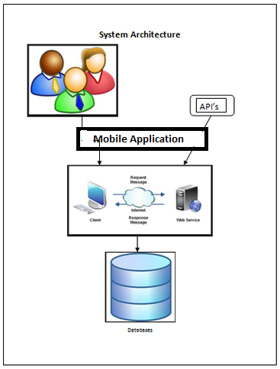

1. **Class Diagram:**

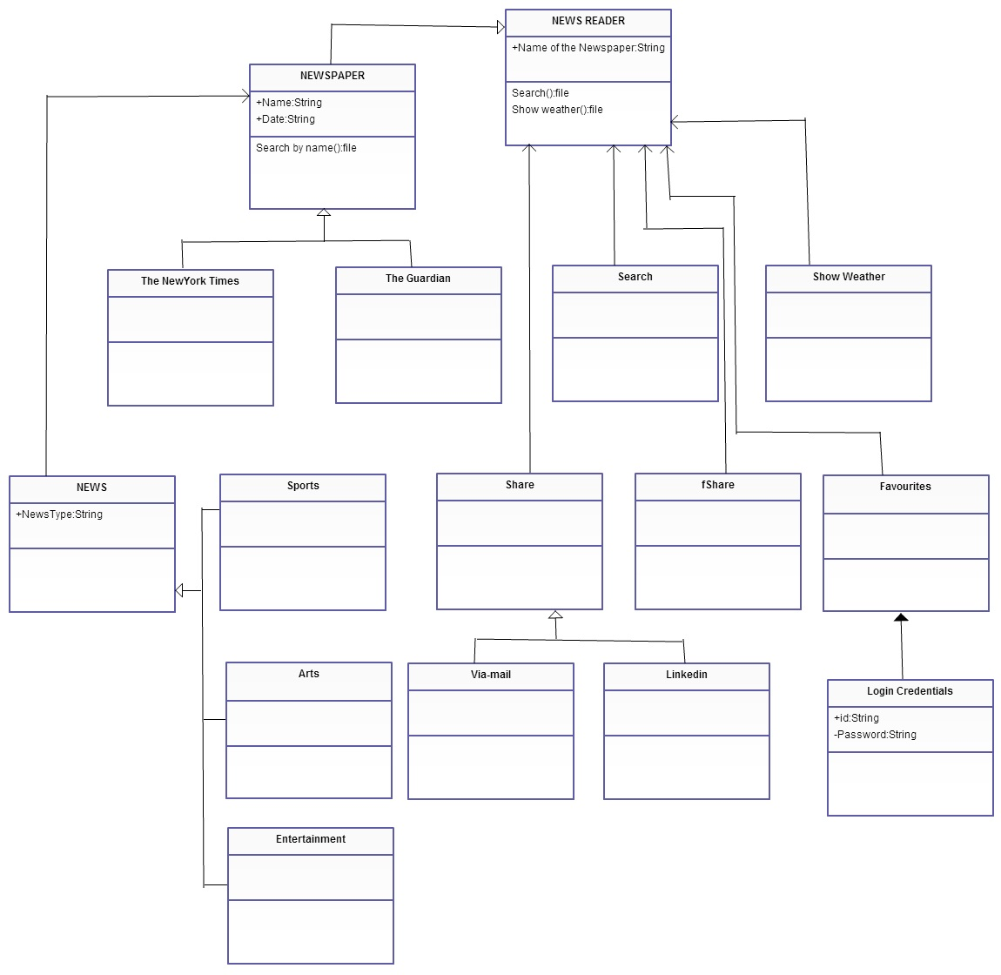

**2. Features Implemented:**

* Home Page
* Services Page
* News Articles
* Share options
* Favorites Page
* User Authentication Page
* Weather Services Page
* Search Page

**3. Tools Used:**

1. **Database:**

We have used two newspapers “Guardian” and “NY-Times” so these databases are used in our project. Reader can share the article in face book or e-mail etc by logging in to his account using the face book database.

1. **Mobile User Interface:** Android
2. **Tools:** Android Development Kit, Eclpise

**3. Screenshots of News Reader:**

This is the home page of our application “News Reader”.



Home page of News Reader

Our application enables users have the news up to date and makes him aware of the environment around him.

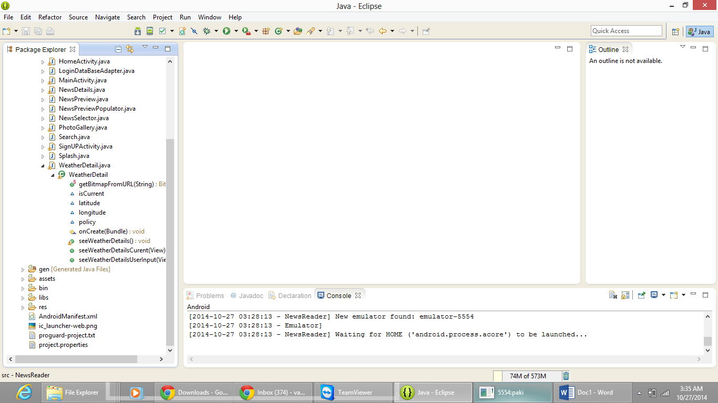

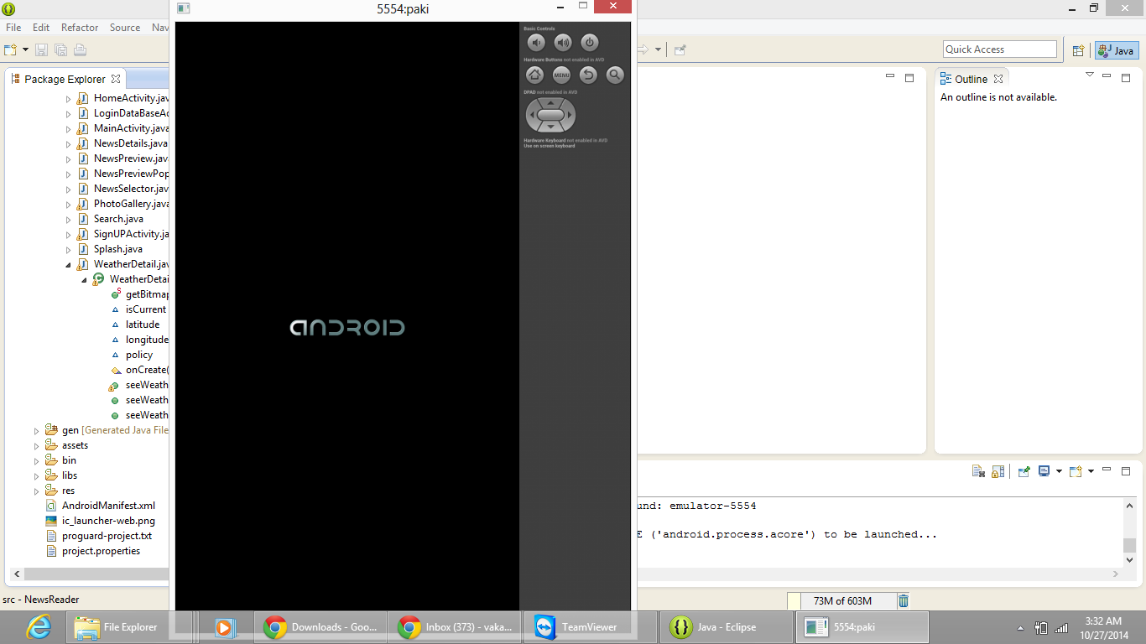

We have used the android development kit and using the emulator we tried to develop our app and the above shown screen shots explains the same.

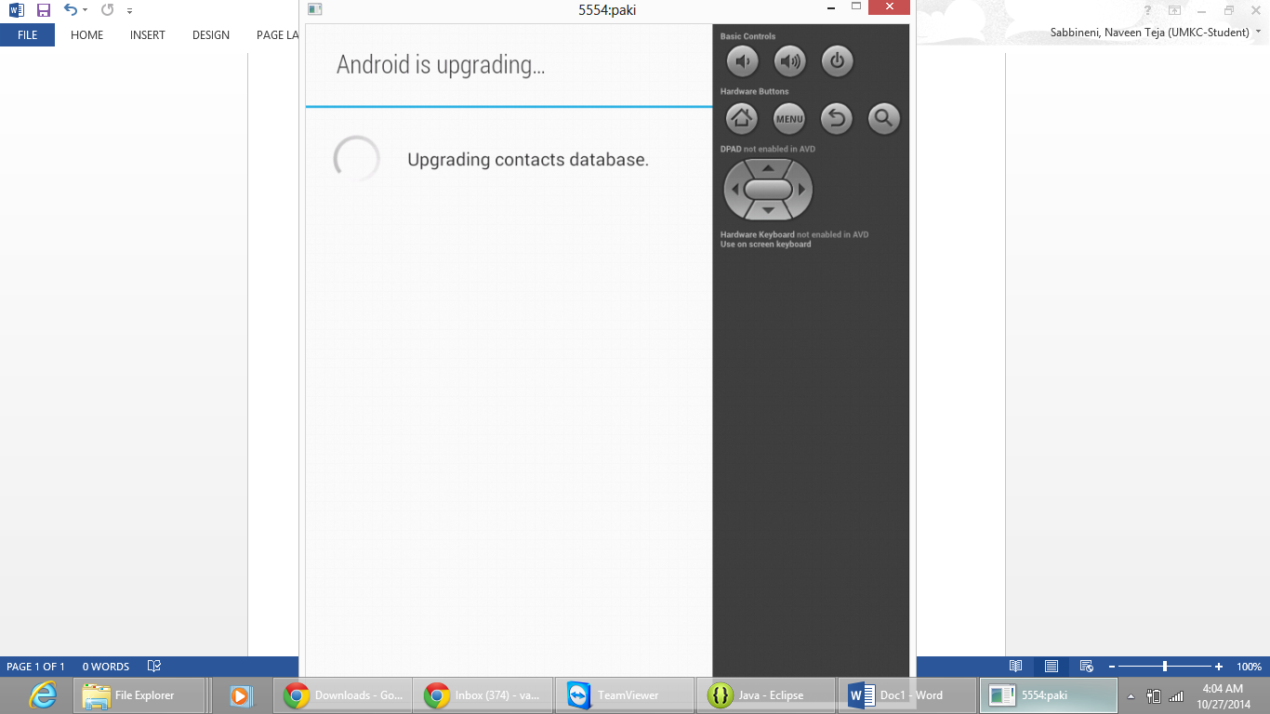

We have two papers in our application so that the reader can select the paper of his choice the screen shot of that is shown below.

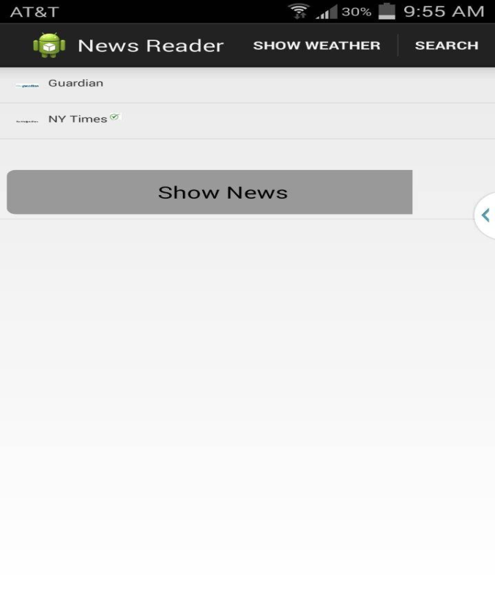

The above screen shot shows two papers one with the name Guardian and the other is NY Times from which the reader selects the paper of his choice. Then he clicks the button “Show News” to fetch the results of his choice.

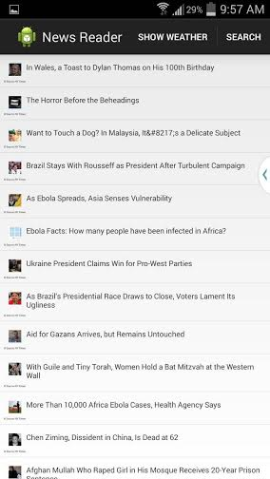

The above screen shot shows that the news with the headlines is enlisted from the particular paper. The reader can select a particular topic based on his interest from all the list of news articles.

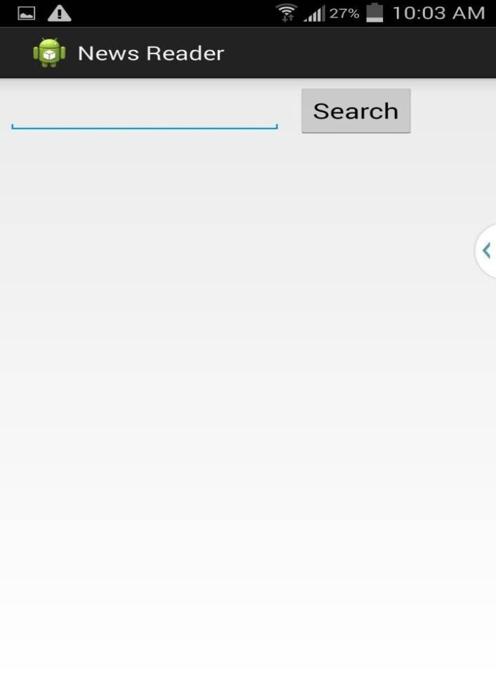

We have the search tool too from which we can type the article whatever we are looking for and can have the news regarding that particular topic. The above screen shot shows the same explanation

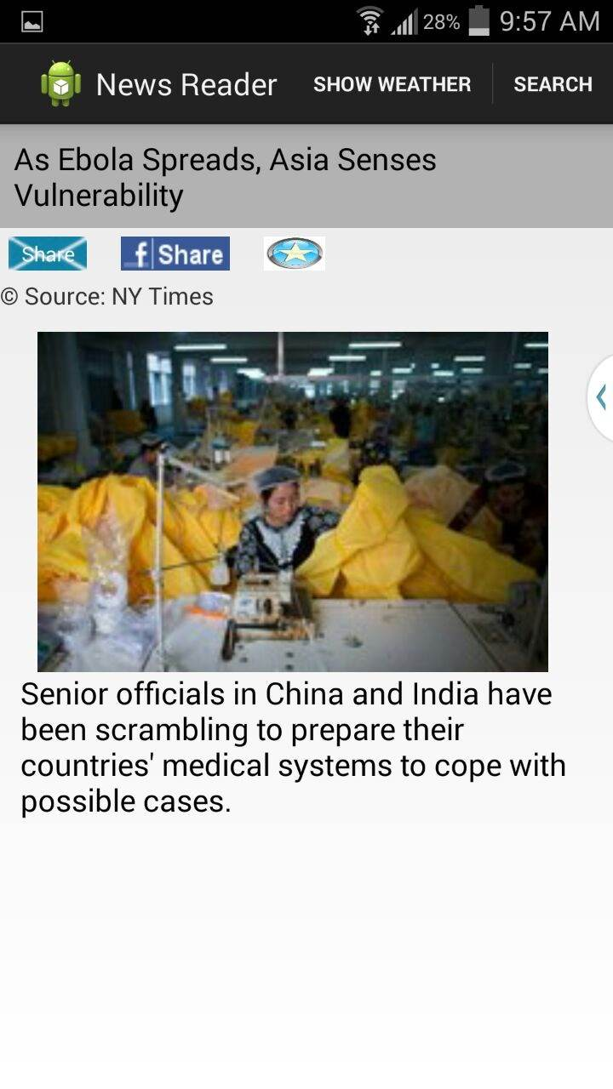

By selecting a particular topic say if the reader has selected the topic “As Ebola spreads, Asia Senses Vulnerability” the news regarding the particular topic with the images concerned are being displayed providing all the news listed in the newspaper about that particular topic.

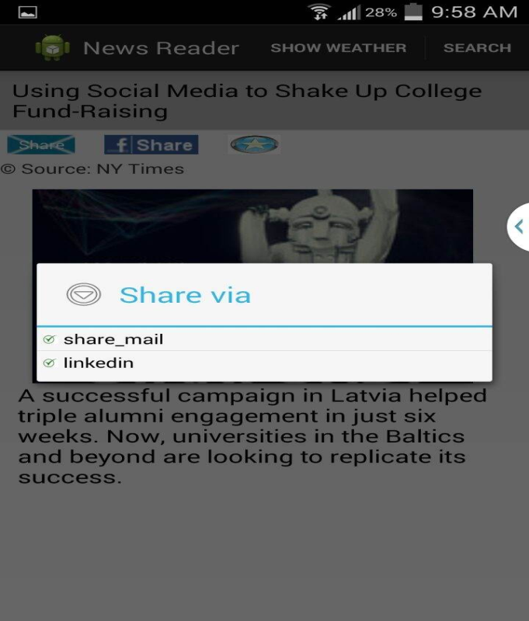

We have features like “Share” which enables reader to have an option of sharing the article what he had read to his peers using the email, face book, LinkedIn etc.

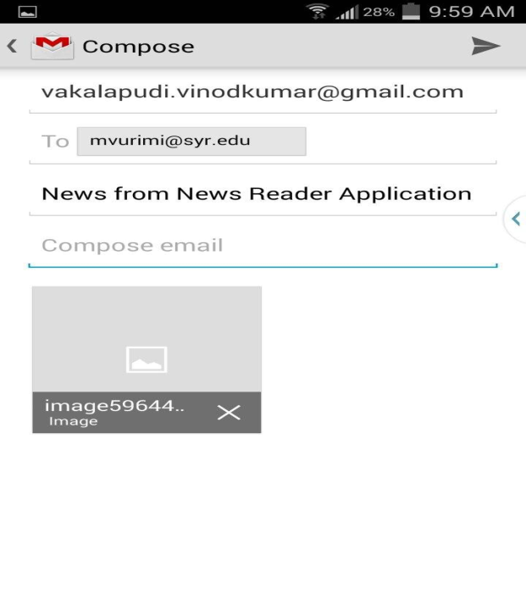

Screen shot which shows the share of an article using Gmail

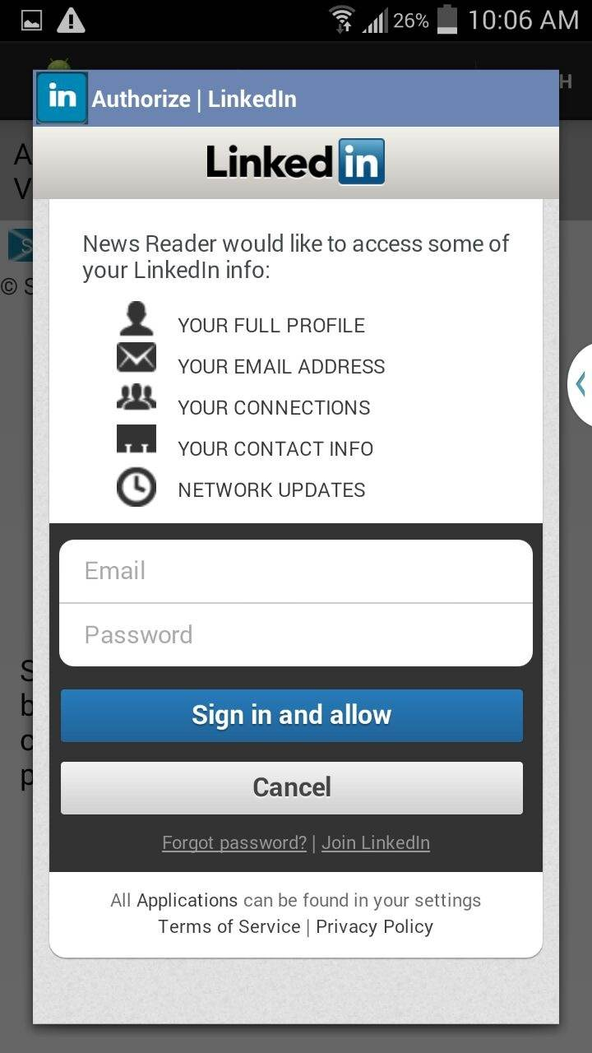

Screen shot which shows the share of an article using LinkedIn



Screen shot which shows the share of an article using Face book

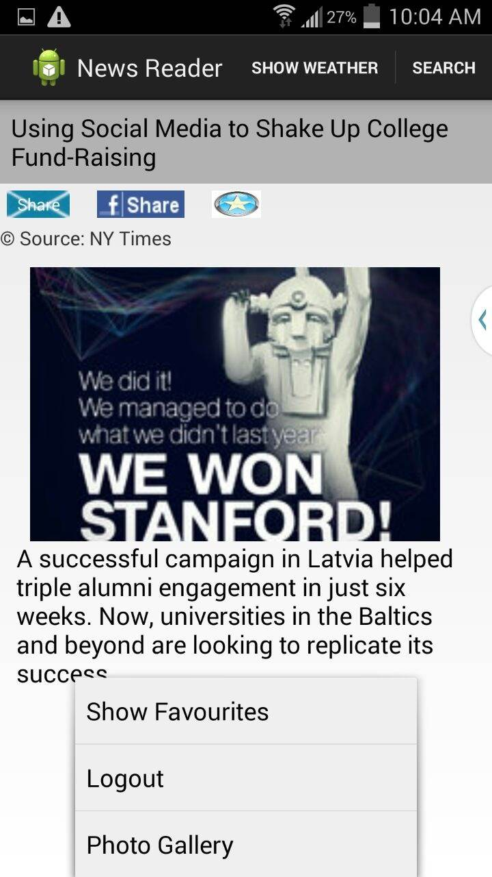

We will be providing the feature like Show Favorites, Logout and Photo Gallery options too in the drop down menu using them we can have the history of all the articles that are being viewed by us as recorded and we can make a particular article favorite and can review it later whenever required.

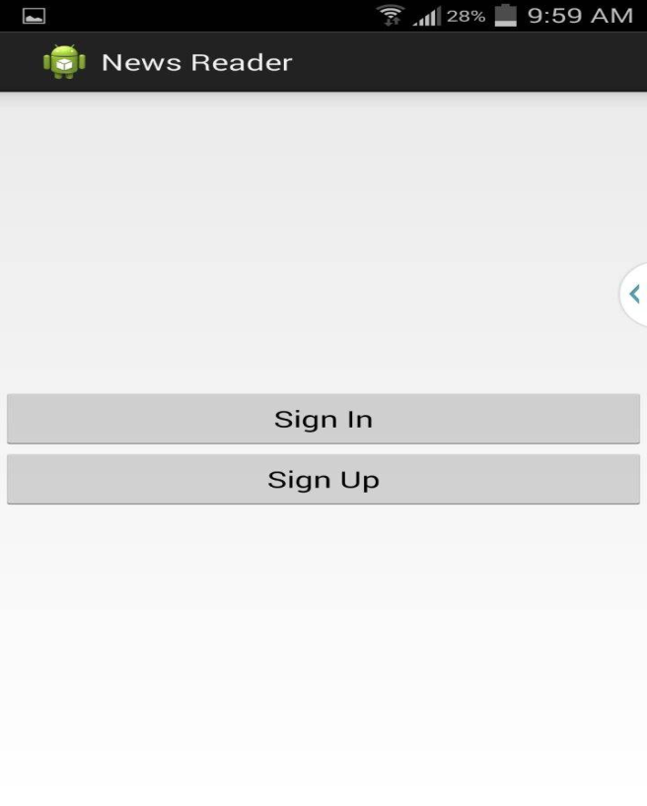

This can be done by the user signup by giving his credentials to our News Reader application.

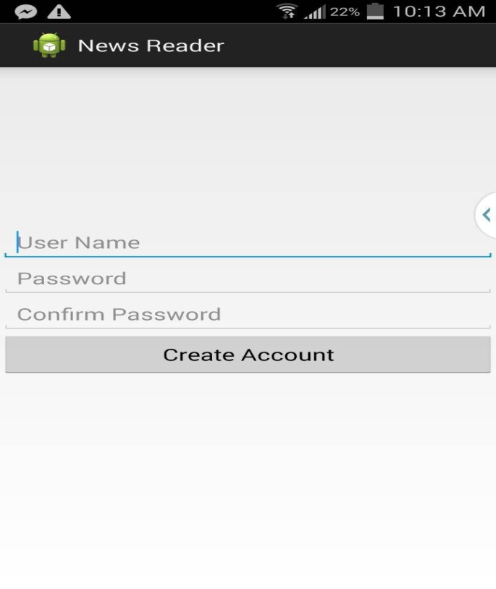

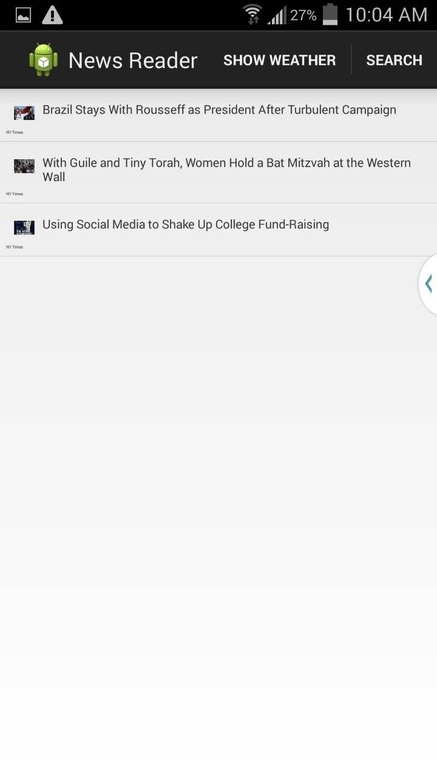

Screen Shot which shows the favorite News Articles

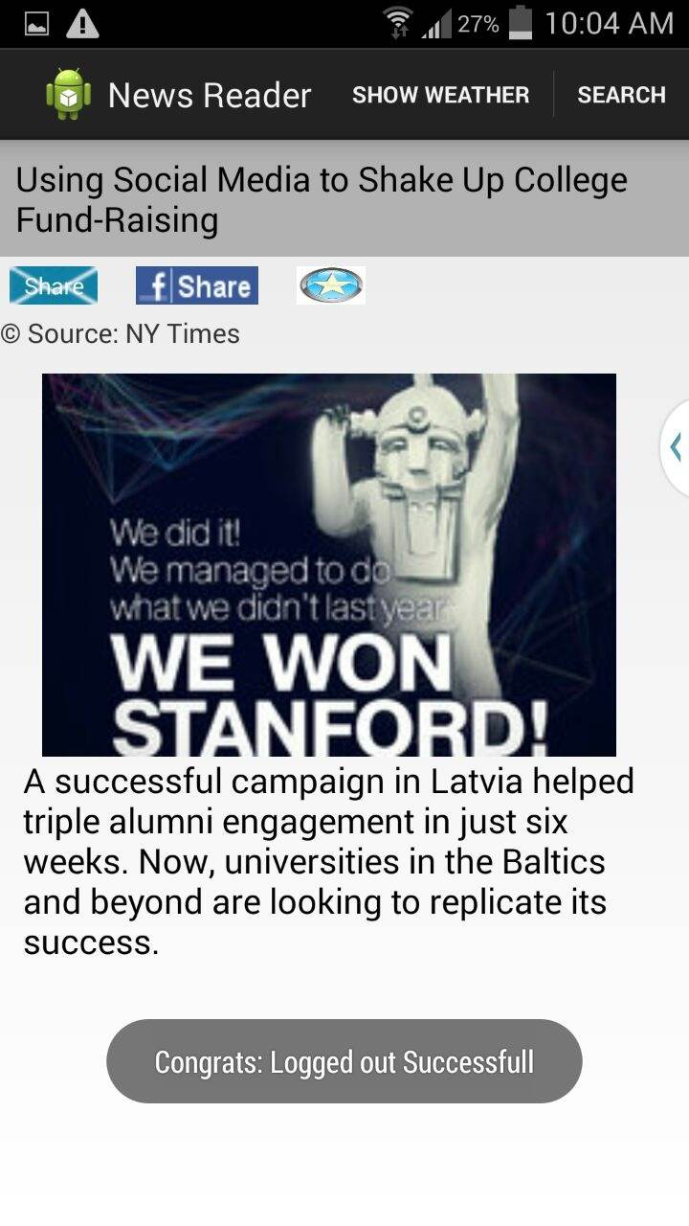

Screen shot shows that the reader has logged out

The User after having read the news and sharing, adding the articles to his favorites can logout from his account and a pop-up message is being displayed as “Congrats: Logged out Succesfull”.

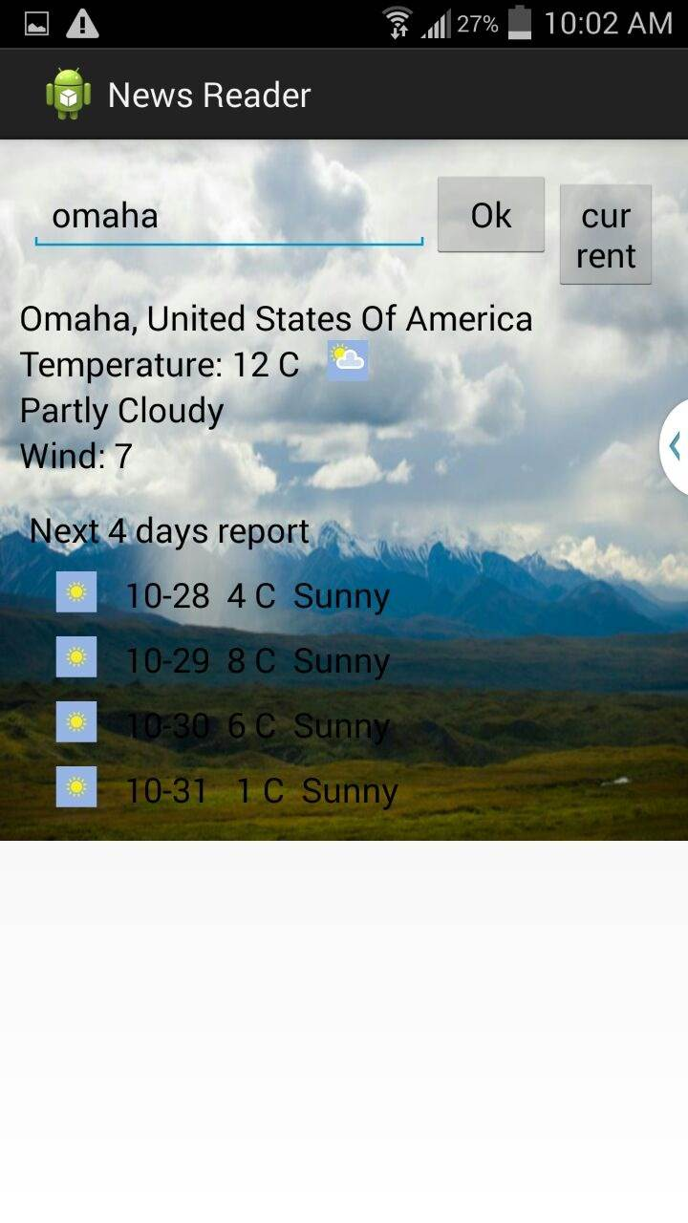

Screen shot showing the weather conditions of a particular place “Omaha”

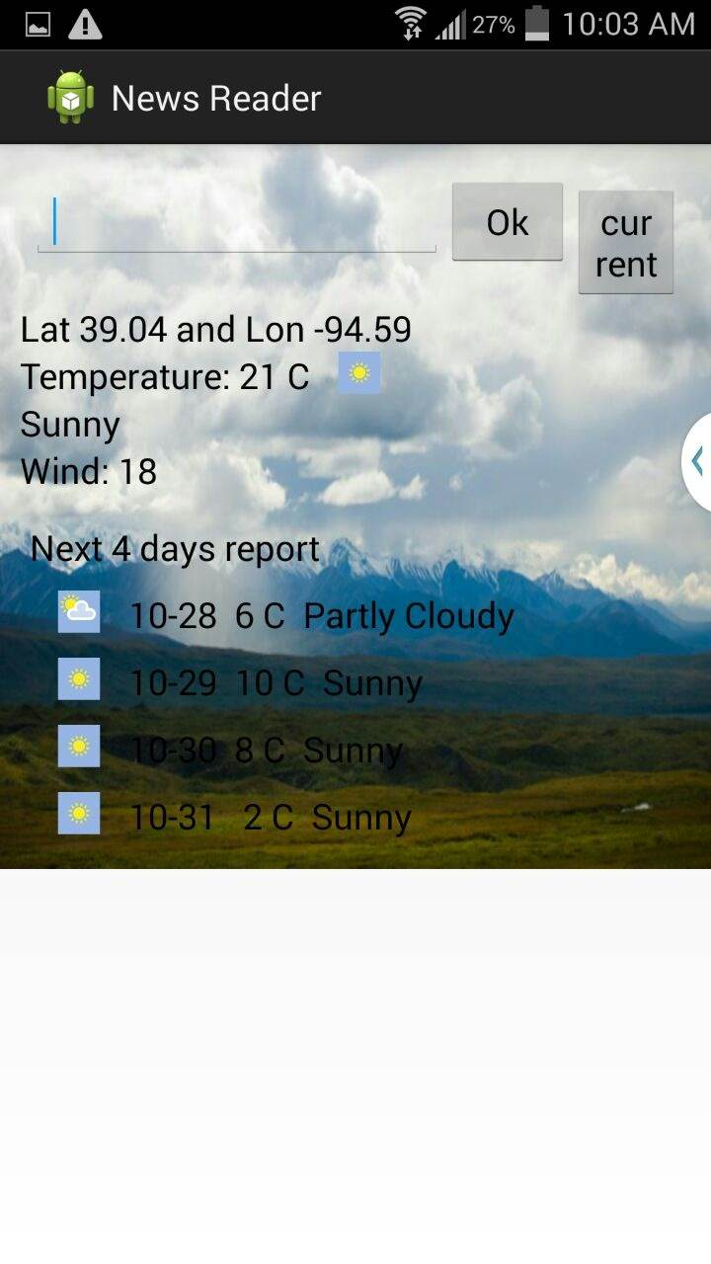

Screen shot displays the weather Conditions of the current location

We have implemented one more feature of displaying the weather. Users can know the temperature of a place where he resides and the place of his interest.

**5. Limitations:**

Our project is confined to two papers only. Due to time constraints it is not implemented with more papers.

**6. Github URL:**

https://github.com/syamalareddy/challenge2.git

**7. References:**

* <http://www3.nd.edu/~cpoellab/teaching/cse40814/android_tutorial.pdf>
* <http://www.nytimes.com/pages/todayspaper/>
* <http://www.theguardian.com/us>
* <http://www.weather.com/>